Name : Deepankar Sharma

Course: BCA

University Roll No: 2092014

Student Id : 20041299

Semester: 5

Date: December 26, 2022

**Practical 01: Hello World App**

**Objective:**  Create an Android Hello World App.

**XML**

<?xml version="1.0" encoding="utf-8"?>

<android.support.constraint.ConstraintLayout xmlns:android="http://schemas.android.com/apk/res/android"

xmlns:app="http://schemas.android.com/apk/res-auto"

xmlns:tools="http://schemas.android.com/tools"

android:layout_width="match_parent"

android:layout_height="match_parent"

tools:context=".MainActivity">

<TextView

android:layout_width="wrap_content"

android:layout_height="wrap_content"

android:text="Hello World!"

app:layout_constraintBottom_toBottomOf="parent"

app:layout_constraintEnd_toEndOf="parent"

app:layout_constraintStart_toStartOf="parent"

app:layout_constraintTop_toTopOf="parent" />

</android.support.constraint.ConstraintLayout>

**JAVA**

package com.example.practicalkimkbkc;

import android.support.v7.app.AppCompatActivity;

import android.os.Bundle;

public class MainActivity extends AppCompatActivity {

@Override

protected void onCreate(Bundle savedInstanceState) {

super.onCreate(savedInstanceState);

setContentView(R.layout.activity_main);

}

}

**Output:**

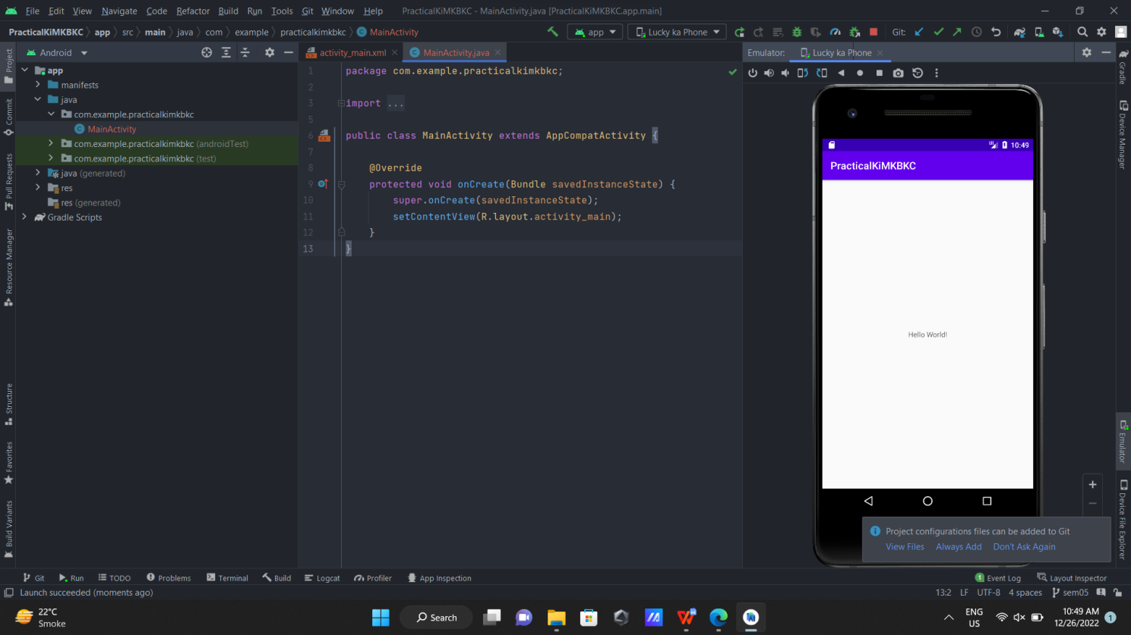

Name : Deepankar Sharma

Course: BCA

University Roll No: 2092014

Student Id : 20041299

Semester: 5

Date: September 12, 2022

**Practical 02: Unit Convertor App**

**Objective:**  Create an Android app to convert kilograms into pounds.

**JAVA CODE**

package com.example.unitconverter;

import androidx.appcompat.app.AppCompatActivity;

import android.os.Bundle;

import android.view.View;

import android.widget.Button;

import android.widget.EditText;

import android.widget.TextView;

import android.widget.Toast;

public class MainActivity extends AppCompatActivity {

private Button b;

private TextView tv;

private EditText et;

@Override

protected void onCreate(Bundle savedInstanceState) {

super.onCreate(savedInstanceState);

setContentView(R.layout.activity_main);

b= findViewById(R.id.button);

tv= findViewById(R.id.textView);

et= findViewById(R.id.editTextTextPersonName);

b.setOnClickListener(new View.OnClickListener() {

@Override

public void onClick(View view) {

Toast.makeText(MainActivity.this, "Converted Successfully !!!", Toast.LENGTH_SHORT).show();

String s= et.getText().toString();

int kg= Integer.parseInt(s);

double pound= kg*2.205;

tv.setText("The corresponding Pounds value is: "+ pound);

}

});

}

}

**Output:**

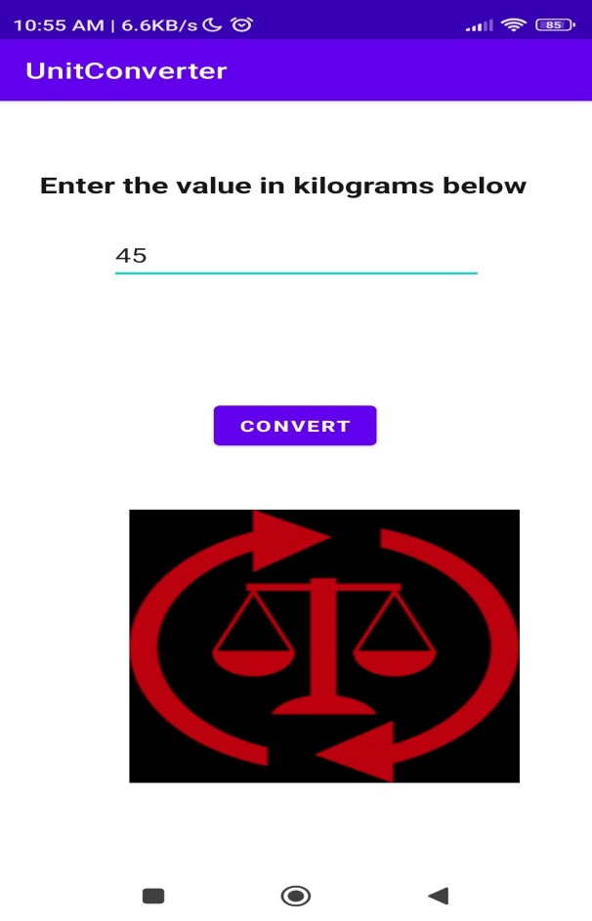

Name : Deepankar Sharma

Course: BCA

University Roll No: 2092014

Student Id : 20041299

Semester: 5

Date: September 12, 2022

**Practical 03: Scorecard App**

**Objective:**  Create an Android app which takes input marks of five subjects and calculates the percentage as output.

**JAVA CODE**

package com.example.percentagecalculator;

import android.support.v7.app.AppCompatActivity;

import android.os.Bundle;

import android.view.View;

import android.widget.Button;

import android.widget.EditText;

import android.widget.TextView;

import android.widget.Toast;

public class MainActivity extends AppCompatActivity {

private Button b;

private EditText e1;

private EditText e2;

private EditText e3;

private EditText e4;

private EditText e5;

private TextView t1;

@Override

protected void onCreate(Bundle savedInstanceState) {

super.onCreate(savedInstanceState);

setContentView(R.layout.activity_main);

b= findViewById(R.id.button);

e1= findViewById(R.id.editTextNumberDecimal);

e2= findViewById(R.id.editTextNumberDecimal2);

e3= findViewById(R.id.editTextNumberDecimal3);

e4= findViewById(R.id.editTextNumberDecimal4);

e5= findViewById(R.id.editTextNumberDecimal5);

t1= findViewById(R.id.textView7);

b.setOnClickListener(new View.OnClickListener() {

@Override

public void onClick(View view) {

Toast.makeText(MainActivity.this,"Done!", Toast.LENGTH_SHORT).show();

String s1= e1.getText().toString();

String s2= e2.getText().toString();

String s3= e3.getText().toString();

String s4= e4.getText().toString();

String s5= e5.getText().toString();

double d1= Double.parseDouble(s1);

double d2= Double.parseDouble(s2);

double d3= Double.parseDouble(s3);

double d4= Double.parseDouble(s4);

double d5= Double.parseDouble(s5);

double sum= d1+d2+d3+d4+d5;

t1.setText("The percentage is: " + sum/5 );

}

});

}

}

**Output:**

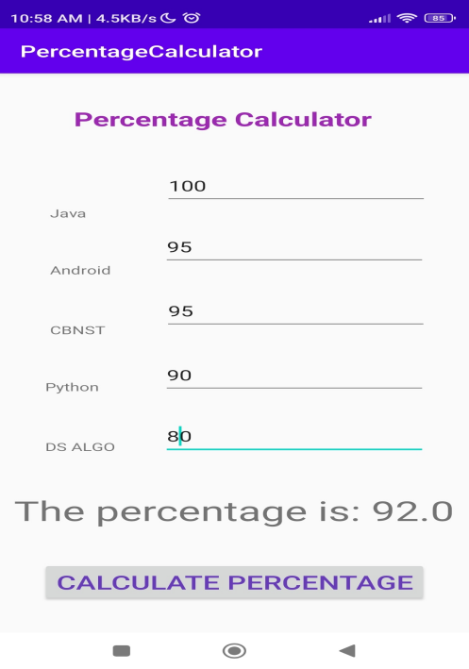

Name : Deepankar Sharma

Course: BCA

University Roll No: 2092014

Student Id : 20041299

Semester: 5

Date: September 12, 2022

**Practical 04: Calculator App**

**Objective:** 4.Scientific calculator (which include java operators, >>, <<, &, ~ etc)

**Java**

package com.example.practicalkimkbkc;

import android.content.Intent;

import android.support.v7.app.AppCompatActivity;

import android.os.Bundle;

import android.view.View;

import android.widget.Button;

import android.widget.EditText;

import android.widget.RadioButton;

import android.widget.TextView;

public class Practical04 extends AppCompatActivity {

TextView t;

EditText e1, e2;

RadioButton r1, r2, r3, r4, r5, r6, r7, r8, r9;

@Override

protected void onCreate(Bundle savedInstanceState) {

super.onCreate(savedInstanceState);

setContentView(R.layout.activity_practical04);

t= findViewById(R.id.textView4);

e1= findViewById(R.id.editTextNumberDecimal3);

e2= findViewById(R.id.editTextNumberDecimal4);

r1= findViewById(R.id.radioButton);

r2= findViewById(R.id.radioButton2);

r3= findViewById(R.id.radioButton3);

r4= findViewById(R.id.radioButton4);

r5= findViewById(R.id.radioButton5);

r6= findViewById(R.id.radioButton6);

r7= findViewById(R.id.radioButton7);

r8= findViewById(R.id.radioButton8);

Button b= findViewById(R.id.button14);

b.setOnClickListener(new View.OnClickListener() {

@Override

public void onClick(View view) {

int num1= Integer.parseInt(e1.getText().toString());

int num2= Integer.parseInt(e2.getText().toString());

if (r1.isChecked()){

String s= Integer.toString(num1+num2);

t.setText(s);

}

else if (r2.isChecked()){

String s= Integer.toString(num1-num2);

t.setText(s);

}

else if (r3.isChecked()){

String s= Integer.toString(num1*num2);

t.setText(s);

}

else if (r4.isChecked()){

String s= Integer.toString(num1/num2);

t.setText(s);

}

else if (r5.isChecked()){

String s= Integer.toString(num1>>num2);

t.setText(s);

}

else if (r6.isChecked()){

String s= Integer.toString(num1<<num2);

t.setText(s);

}

else if (r7.isChecked()){

String s= Integer.toString(num1&num2);

t.setText(s);

}

else if (r8.isChecked()){

String s= Integer.toString(num1|num2);

t.setText(s);

}

}

});

}

}

**Output**

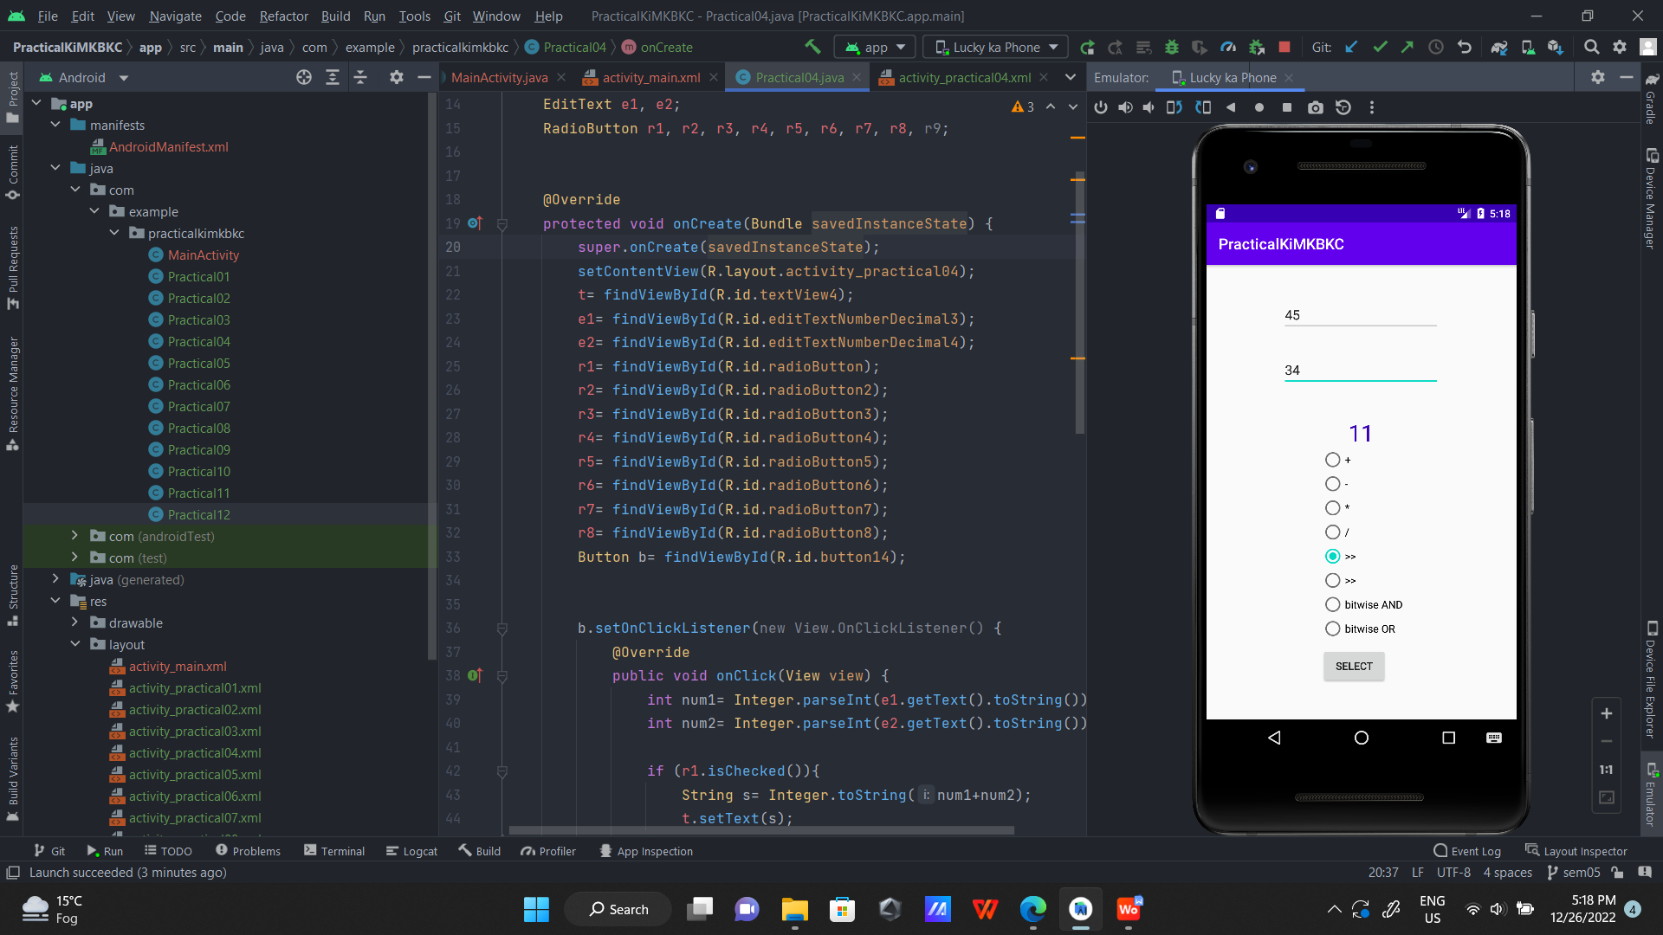

**Practical 05: Change Icon**

**Objective:**  Change the app icon image.

**AndroidManifest.xml**

<?xml version="1.0" encoding="utf-8"?>

<manifest xmlns:android="http://schemas.android.com/apk/res/android"

xmlns:tools="http://schemas.android.com/tools"

package="com.example.practicalkimkbkc">

<application

android:allowBackup="true"

android:dataExtractionRules="@xml/data_extraction_rules"

android:fullBackupContent="@xml/backup_rules"

**android:icon="@mipmap/new_icon"**

android:label="@string/app_name"

android:roundIcon="@mipmap/ic_launcher_round"

android:supportsRtl="true"

android:theme="@style/Theme.PracticalKiMKBKC"

tools:targetApi="31">

<activity

android:name=".Practical12"

android:exported="false" />

<activity

android:name=".Practical11"

android:exported="false" />

<activity

android:name=".Practical10"

android:exported="false" />

<activity

android:name=".Practical09"

android:exported="false" />

<activity

android:name=".Practical08"

android:exported="false" />

<activity

android:name=".Practical07"

android:exported="false" />

<activity

android:name=".Practical06"

android:exported="false" />

<activity

android:name=".Practical05"

android:exported="false" />

<activity

android:name=".Practical04"

android:exported="false" />

<activity

android:name=".Practical03"

android:exported="false" />

<activity

android:name=".Practical02"

android:exported="false" />

<activity

android:name=".Practical01"

android:exported="false" />

<activity

android:name=".MainActivity"

android:exported="true">

<intent-filter>

<action android:name="android.intent.action.MAIN" />

<category android:name="android.intent.category.LAUNCHER" />

</intent-filter>

</activity>

</application>

</manifest>

**Output:**

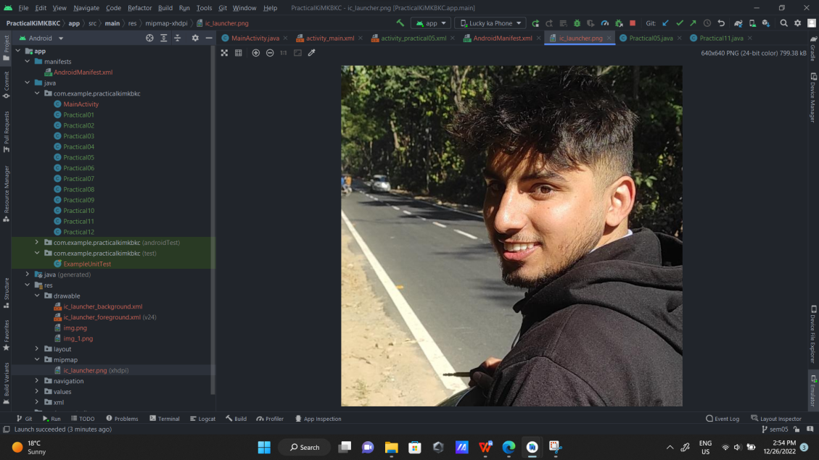 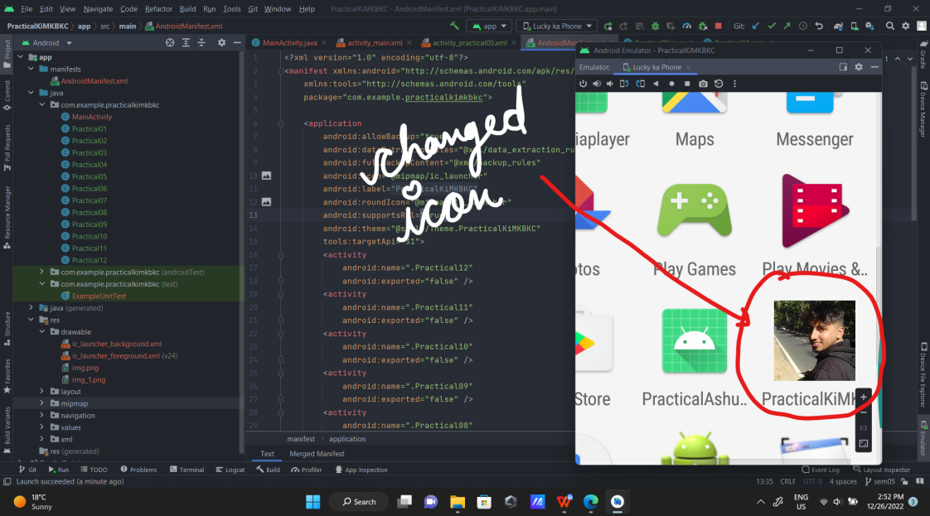

Name : Deepankar Sharma

Course: BCA

University Roll No: 2092014

Student Id : 20041299

Semester: 5

Date: December 26, 2022

**Practical 06: Demo Toast**

**Objective:**  Create an Android app to demonstrate Toast.

**Java**

package com.example.practicalkimkbkc;

import android.content.Intent;

import android.support.v7.app.AppCompatActivity;

import android.os.Bundle;

import android.view.View;

import android.widget.Toast;

public class Practical06 extends AppCompatActivity {

@Override

protected void onCreate(Bundle savedInstanceState) {

super.onCreate(savedInstanceState);

setContentView(R.layout.activity_practical06);

}

public void home(View v){

Intent i= new Intent(this, MainActivity.class);

Toast.makeText(this, "Going Back to Home", Toast.LENGTH_LONG).show();

startActivity(i);

}

public void show_toast(View v){

Toast.makeText(this,"Amazing Toast !!!!", Toast.LENGTH_LONG).show();

}

}

**Output:**

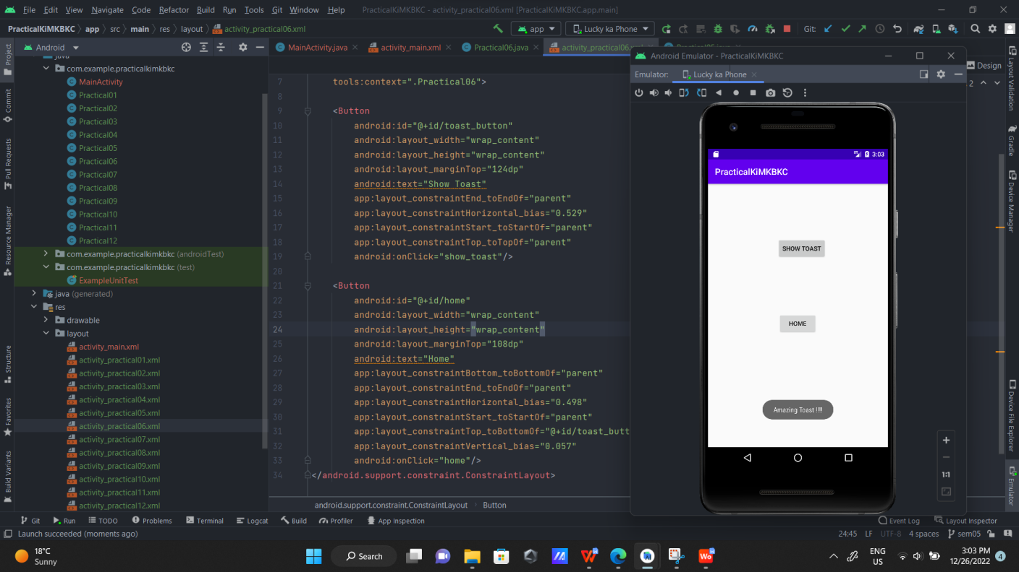

Name : Deepankar Sharma

Course: BCA

University Roll No: 2092014

Student Id : 20041299

Semester: 5

Date: December 26, 2022

**Practical 07: View Demo**

**Objective:**  Create an Android app for demonstration of button, edit view, text view and setting click listeners.

**JAVA:**

package com.example.practicalkimkbkc;

import android.content.Intent;

import android.support.v7.app.AppCompatActivity;

import android.os.Bundle;

import android.view.View;

import android.widget.Button;

import android.widget.EditText;

import android.widget.TextView;

import android.widget.Toast;

public class Practical07 extends AppCompatActivity {

TextView tv;

EditText et;

Button b;

@Override

protected void onCreate(Bundle savedInstanceState) {

super.onCreate(savedInstanceState);

setContentView(R.layout.activity_practical07);

tv= findViewById(R.id.textView2);

et= findViewById(R.id.editTextTextPersonName);

b= findViewById(R.id.button5);

b.setOnClickListener(new View.OnClickListener() {

@Override

public void onClick(View view) {

String name= et.getText().toString();

name= "Your name is "+ name;

tv.setText(name);

}

});

}

public void home(View v){

Intent i= new Intent(this, MainActivity.class);

Toast.makeText(this, "Going Back to Home", Toast.LENGTH_LONG).show();

startActivity(i);

}

}

**Output:**

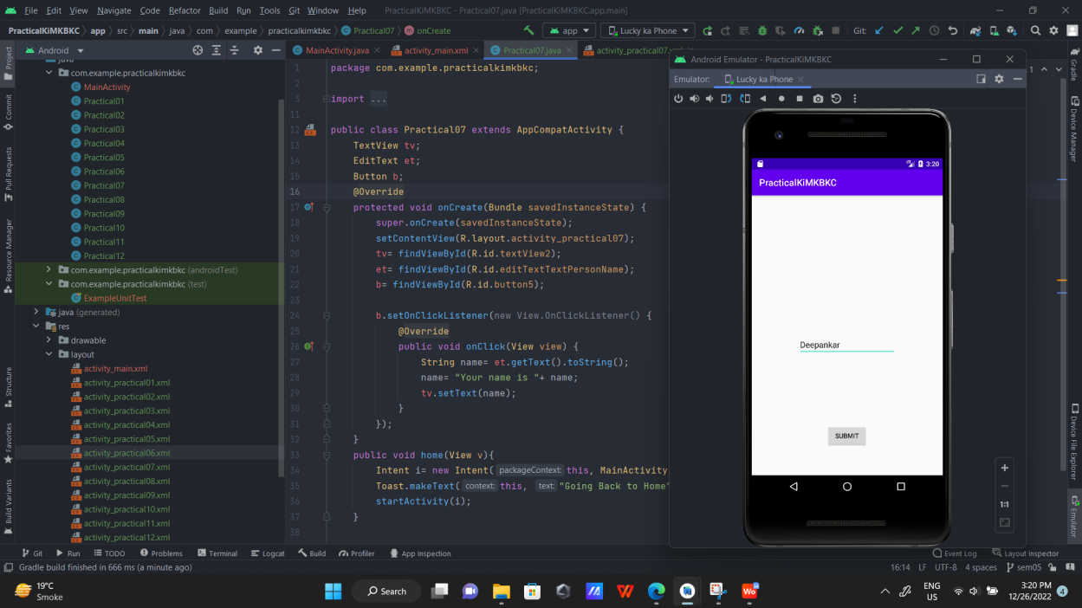 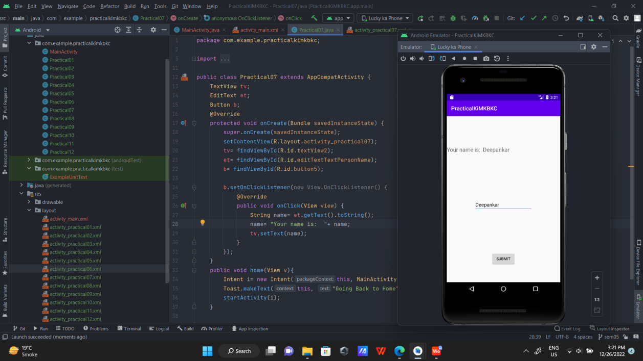

Name : Deepankar Sharma

Course: BCA

University Roll No: 2092014

Student Id : 20041299

Semester: 5

Date: December 26, 2022

**Practical 08: Media Player App**

**Objective:**  Create an Android app media player.

**JAVA CODE**

package com.example.kycmediaplayer;

import android.support.v7.app.AppCompatActivity;

import android.os.Bundle;

import android.view.View;

import android.widget.Button;

import android.widget.MediaController;

import android.widget.VideoView;

public class MainActivity extends AppCompatActivity {

Button b;

VideoView v;

MediaController mc;

@Override

protected void onCreate(Bundle savedInstanceState) {

super.onCreate(savedInstanceState);

setContentView(R.layout.activity_main);

b= findViewById(R.id.button);

v= findViewById(R.id.vv);

mc= new MediaController(this);

}

public void playVideo(View view){

String path= "android.resource://"+ getPackageName()+"/"+R.raw.video;

v.setMediaController(mc);

mc.setAnchorView(v);

v.setVideoPath(path);

v.start();

}

}

**Output:**

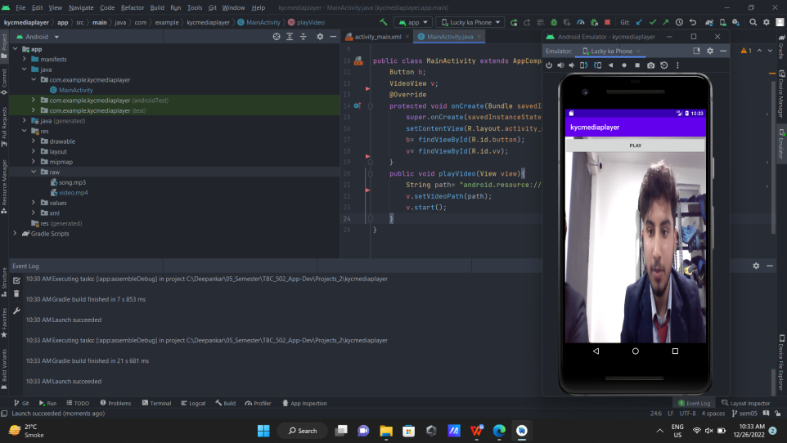

Name : Deepankar Sharma

Course: BCA

University Roll No: 2092014

Student Id : 20041299

Semester: 5

Date: December 26, 2022

**Practical 09: Setting Media Controllers App**

**Objective:**  Create an Android app media player and set the media controllers.

**XML CODE**

<?xml version="1.0" encoding="utf-8"?>

<android.support.constraint.ConstraintLayout xmlns:android="http://schemas.android.com/apk/res/android"

xmlns:app="http://schemas.android.com/apk/res-auto"

xmlns:tools="http://schemas.android.com/tools"

android:layout_width="match_parent"

android:layout_height="match_parent"

tools:context=".MainActivity">

<Button

android:id="@+id/button"

android:layout_width="match_parent"

android:layout_height="wrap_content"

android:text="@string/play"

app:layout_constraintBottom_toBottomOf="parent"

app:layout_constraintEnd_toEndOf="parent"

app:layout_constraintHorizontal_bias="0.439"

app:layout_constraintStart_toStartOf="parent"

app:layout_constraintTop_toTopOf="parent"

app:layout_constraintVertical_bias="0.004"

android:onClick="playVideo"/>

<VideoView

android:id="@+id/vv"

android:layout_width="match_parent"

android:layout_height="match_parent"

tools:layout_editor_absoluteX="-55dp"

tools:layout_editor_absoluteY="-16dp" />

</android.support.constraint.ConstraintLayout>

**JAVA CODE**

package com.example.kycmediaplayer;

import android.support.v7.app.AppCompatActivity;

import android.os.Bundle;

import android.view.View;

import android.widget.Button;

import android.widget.MediaController;

import android.widget.VideoView;

public class MainActivity extends AppCompatActivity {

Button b;

VideoView v;

MediaController mc;

@Override

protected void onCreate(Bundle savedInstanceState) {

super.onCreate(savedInstanceState);

setContentView(R.layout.activity_main);

b= findViewById(R.id.button);

v= findViewById(R.id.vv);

mc= new MediaController(this);

}

public void playVideo(View view){

String path= "android.resource://"+ getPackageName()+"/"+R.raw.video;

v.setMediaController(mc);

mc.setAnchorView(v);

v.setVideoPath(path);

v.start();

}

}

**Output:**

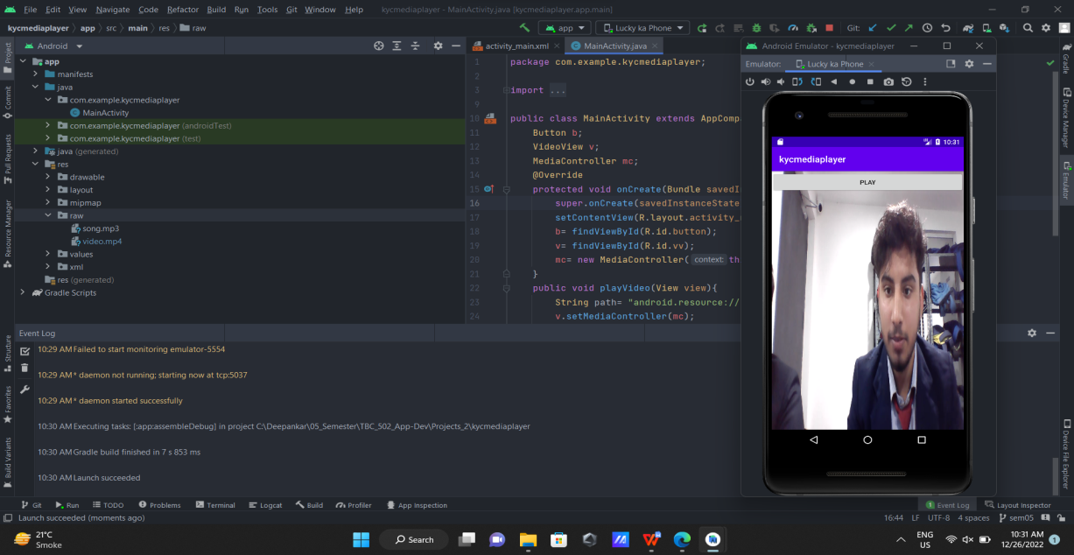

Name : Deepankar Sharma

Course: BCA

University Roll No: 2092014

Student Id : 20041299

Semester: 5

Date: December 26, 2022

**Practical 10: Intent App**

**Objective:**  Create an Android app to demonstrate intent.

**Java**

package com.example.practicalkimkbkc;

import android.content.Intent;

import android.support.v7.app.AppCompatActivity;

import android.os.Bundle;

import android.view.View;

import android.widget.Toast;

public class Practical10 extends AppCompatActivity {

@Override

protected void onCreate(Bundle savedInstanceState) {

super.onCreate(savedInstanceState);

setContentView(R.layout.activity_practical10);

}

public void home(View v){

Intent i= new Intent(this, MainActivity.class);

Toast.makeText(this, "Going Back to Home", Toast.LENGTH_LONG).show();

startActivity(i);

}

}

**Output:**

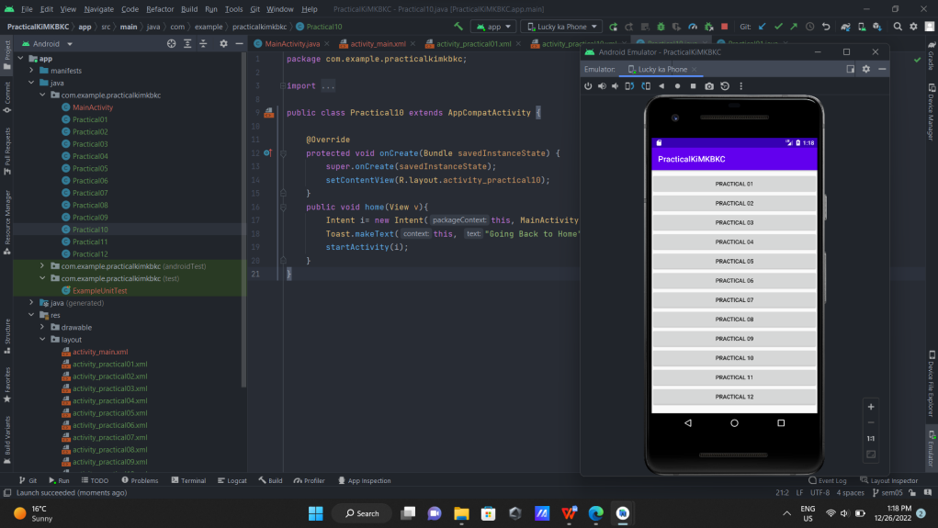

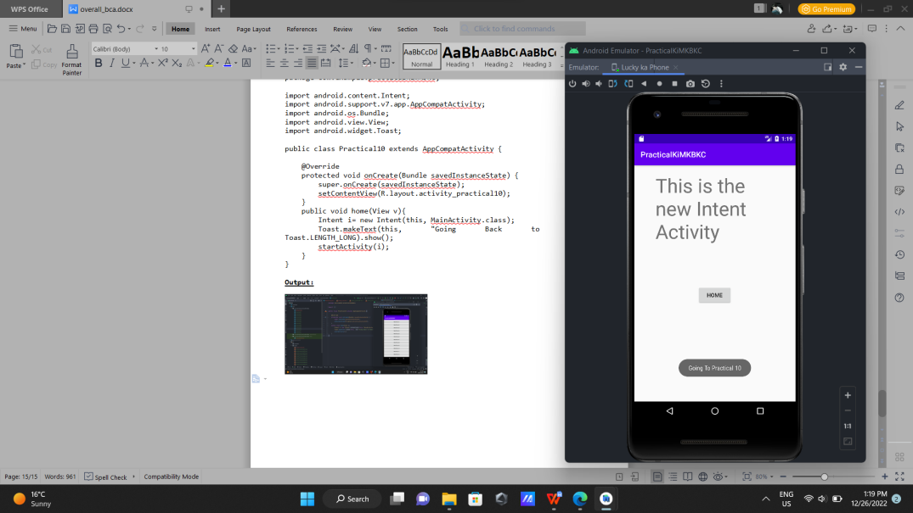

**Practical 11: Image View App**

**Objective:**  Create an Android app to set image in image view.

**Java**

package com.example.practicalkimkbkc;

import android.content.Intent;

import android.graphics.drawable.BitmapDrawable;

import android.graphics.drawable.Drawable;

import android.support.v7.app.AppCompatActivity;

import android.os.Bundle;

import android.view.View;

import android.widget.ImageView;

import android.widget.Toast;

public class Practical11 extends AppCompatActivity {

private ImageView iv;

@Override

protected void onCreate(Bundle savedInstanceState) {

super.onCreate(savedInstanceState);

setContentView(R.layout.activity_practical11);

iv= findViewById(R.id.imageView);

}

public void home(View v){

Intent i= new Intent(this, MainActivity.class);

Toast.makeText(this, "Going Back to Home", Toast.LENGTH_LONG).show();

startActivity(i);

}

public void img_v(View v){

iv.setImageResource(R.drawable.img);

Toast.makeText(this, "Set the Picture", Toast.LENGTH_LONG).show();

}

}

**Output:**

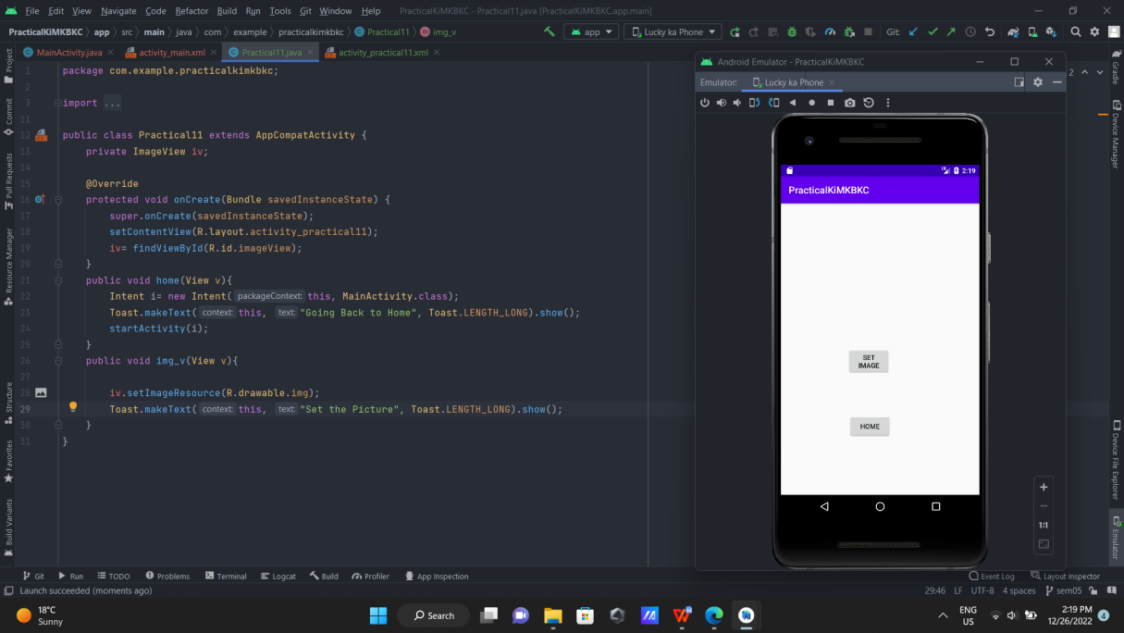

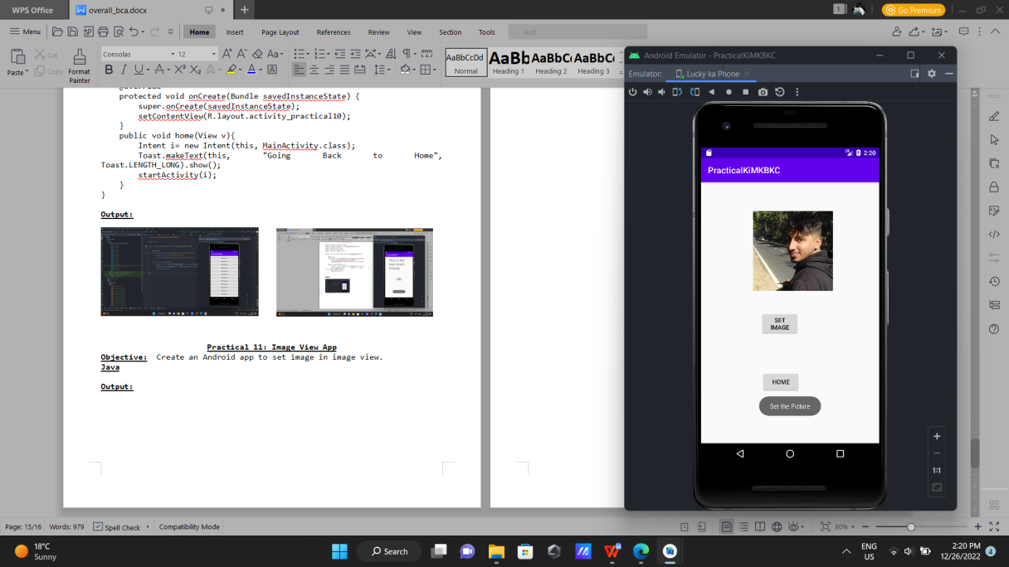

**Practical 12: Simple Quiz App**

**Objective:**  Create an Android app for designing a quiz application.

**Java**

package com.example.practicalkimkbkc;

import static android.widget.Toast.*;

import android.support.v7.app.AppCompatActivity;

import android.os.Bundle;

import android.view.View;

import android.widget.Button;

import android.widget.RadioButton;

import android.widget.RadioGroup;

import android.widget.TextView;

import android.widget.Toast;

public class Practical12 extends AppCompatActivity {

TextView t;

RadioButton r1, r2, r3;

RadioGroup rg;

Button b;

@Override

protected void onCreate(Bundle savedInstanceState) {

super.onCreate(savedInstanceState);

setContentView(R.layout.activity_practical12);

t= findViewById(R.id.textView5);

r1= findViewById(R.id.radioButton9);

r2= findViewById(R.id.radioButton10);

r3= findViewById(R.id.radioButton11);

rg= findViewById(R.id.radioGroup);

r2.setOnClickListener(new View.OnClickListener() {

@Override

public void onClick(View view) {

t.setText("Right");

}

});

r1.setOnClickListener(new View.OnClickListener() {

@Override

public void onClick(View view) {

t.setText("Wrong");

}

});

r3.setOnClickListener(new View.OnClickListener() {

@Override

public void onClick(View view) {

t.setText("Wrong");

}

});

}

}

**Output:**

